EXPERIMENT – FIFA WORLD CUP 2026 PLAYER PERFORMANCE

AIM
To import and inspect the FIFA World Cup 2026 Player Performance dataset using Pandas, perform exploratory data analysis by viewing records, dataset information, shape, columns and data types, and export the dataset into CSV, Excel and SQLite database formats.

PROGRAM
import os
import pandas as pd
import sqlite3
# Dataset path
path = "/content"
# Directly use the provided CSV file path
csv_file = "fifa_world_cup_2026_player_performance.csv"
print("CSV file:", csv_file)
# Load dataset
df = pd.read_csv(
os.path.join(path, csv_file),
low_memory=False
)
print("\nFirst 5 rows:")
display(df.head())
print("\nLast 5 rows:")
display(df.tail())
print("\nDataset Information:")
df.info()
print("\nShape:")
print(df.shape)
print("\nColumns:")
print(df.columns.tolist())
print("\nData Types:")
print(df.dtypes)
print("\nStatistical Description:")
display(df.describe().T)
print("\nMissing Values:")
display(df.isnull().sum().sort_values(ascending=False))
print("\nDuplicate Rows:")
print(df.duplicated().sum())
print("\nTeams:")
display(df["team"].value_counts().head(10))
print("\nPositions:")
display(df["position"].value_counts())
print("\nNationalities:")
display(df["nationality"].value_counts().head(10))
print("\nCorrelation:")
display(df.corr(numeric_only=True))
# Export CSV
df.to_csv(
"fifa_player_performance_cleaned.csv",
index=False
)
# Export Excel
df.to_excel(
"fifa_player_performance.xlsx",
index=False
)
# SQLite Database
conn = sqlite3.connect(
"fifa_player_performance.db"
)
df.to_sql(
"player_performance",
conn,
if_exists="replace",
index=False
)
conn.close()
print(
"\nCSV, Excel and SQLite database files "
"created successfully."
)

OUTPUT
The following is the actual Jupyter Notebook output provided for this program:
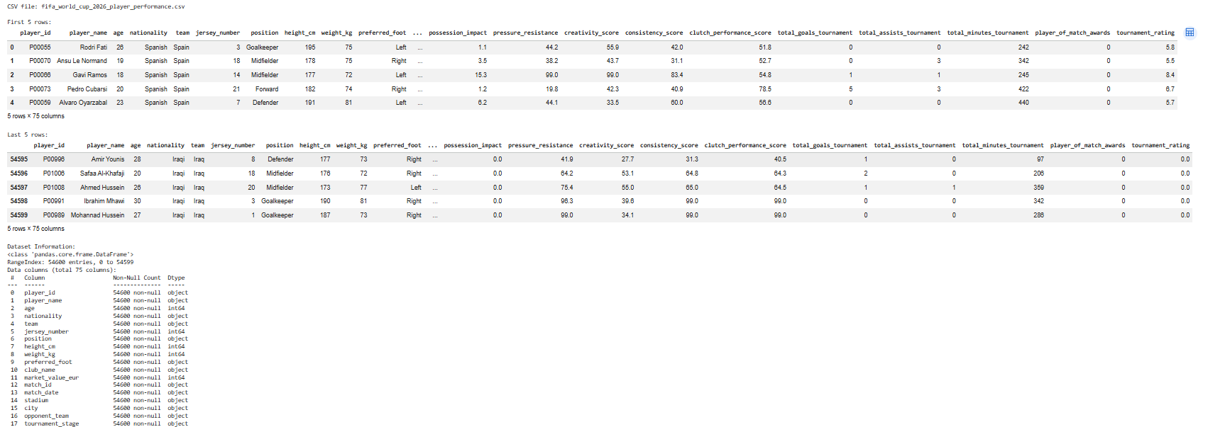
Figure: Actual Jupyter Notebook output

OBSERVED OUTPUT
- CSV file: fifa_world_cup_2026_player_performance.csv
- First 5 rows are displayed successfully.
- Last 5 rows are displayed successfully.
- Dataset contains 54,600 entries and 75 columns.
- The displayed Dataset Information shows 54,600 non-null values for the columns visible in the output.
- The displayed rows include player_id, player_name, age, nationality, team, jersey_number, position, height_cm, weight_kg, preferred_foot and other performance-related columns.

RESULT
Thus, the FIFA World Cup 2026 Player Performance dataset was successfully loaded into Pandas and inspected in Jupyter Notebook. The actual output shows 54,600 entries and 75 columns, with the first and last five records displayed successfully. The dataset information and column details were also successfully obtained.

